**------------------Comparing Files---------------**

**18. cmp :-**

It will compare byte by byte.

cmp file1.txt file2.txt

If content is same then we won't get any output.

If the content is different, then it provides information about only first difference. byte number and line number will be provided.

$ cmp a.txt c.txt

a.txt c.txt differ: byte 7, line 2

Note: cmp command won't show all differences and show only first difference.

**19. diff:-**

It will show all differences in the content.

diff file1.txt file2.txt If the content is the same then no output. If the content is different then it will show all differences

-q shows message when files are different.

-s shows message when files are same | identical

-y shows comparison line by line (parallel comparison)

-i ignore the uppercase and lowercase

         <          file1          >          file2

         c  = change          d = delete          a = add

3,4d2   delete line 3 and line 4 in order to reduce the file to 2 lines equal.

3,6d2  delete line 3 and line 6 in order to reduce the file to 2 lines and make equal.

4a5,7  after line 4 add lines 5 to 7 in first file.

**20. sdiff :-**

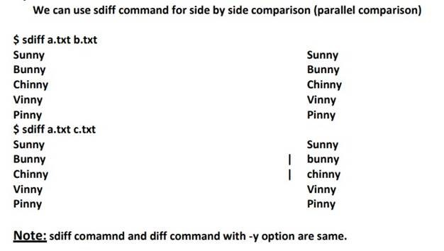

**21. comm**

By using this command we can compare data of two sorted  files.

comm file1.txt file2.txt It display results in 3 columns column-1: Data present only in file1.txt but not in file2.txt column-2: Data present only in file2.txt but not in file1.txt column-3: Common data of both files.

With comm command we can use the following options

If we don't want to display column-1

If we don't want to display column-2

If we don't want to display column-3

IMG_260

    -12     If we don't want to display columns 1 and 2